PROJECT REPORT

Project Title : Educational Organisation Using ServiceNow

1. INTRODUCTION

1.1 Project Overview
The project titled “Educational Organisation Using ServiceNow” is designed to digitize and automate the core administrative operations of an educational institution using the ServiceNow platform. The system provides a centralized digital environment to manage student admissions, academic progress tracking, and administrative workflows efficiently.
The application leverages ServiceNow’s low-code/no-code capabilities to create custom tables, structured forms, automated workflows, and client-side scripting. The system integrates Salesforce (Master Data), Admission, and Student Progress tables to ensure smooth data flow across different stages of a student’s academic lifecycle.
By implementing automation using JavaScript client scripts and process flows, the project significantly reduces manual intervention, improves data accuracy, and enhances administrative efficiency.

1.2 Purpose
The primary purpose of this project is to reduce manual administrative workload in educational institutions by implementing an automated service management system using ServiceNow.
The solution focuses on automating student admission processes, maintaining centralized student records, calculating academic performance automatically, ensuring data accuracy and security, and providing real-time visibility into student records.

2. IDEATION PHASE

2.1 Problem Statement
Educational institutions often manage student admissions and academic records manually or using disconnected systems. This results in data redundancy, processing delays, errors in record management, and difficulty in tracking student performance. There is a need for a centralized, automated system that can efficiently manage admissions and academic tracking in a structured and reliable manner.

2.2 Empathy Map Canvas
Users:
- Educational Institution Administrators
- Admission Coordinators
- Academic Staff
Needs:
- Centralized access to student data
- Automated record management
- Easy academic progress tracking
Pains:
- Manual data entry
- Time-consuming admission processing
- Difficulty in monitoring performance
Gains:
- Faster admission processing
- Real-time student record visibility
- Improved administrative efficiency

2.3 Brainstorming
Based on the identified problem, the following ideas were considered during brainstorming:
• Use ServiceNow as a centralized digital platform
• Create custom tables: Salesforce, Admission, Student Progress
• Design structured forms for easy data entry
• Implement Process Flow Formatter for admission lifecycle tracking
• Use Client Scripts for validation and calculations
• Generate real-time academic result calculations

3. REQUIREMENT ANALYSIS

3.1 Customer Journey Map
- Registration: Student master data is entered into the Salesforce table and a unique SAL ID is generated.
- Enrollment: The Admission table retrieves student data automatically using Reference fields and Client Scripts.
- Evaluation: Marks are entered in the Student Progress table. Total, Percentage, and Result are calculated automatically.

3.2 Solution Requirements
• Unique Identification using Number Maintenance.
• Automated data flow from Salesforce to Admission.
• Instant calculation of Total, Percentage, and Result.
• Disabled calculation fields to ensure data security.

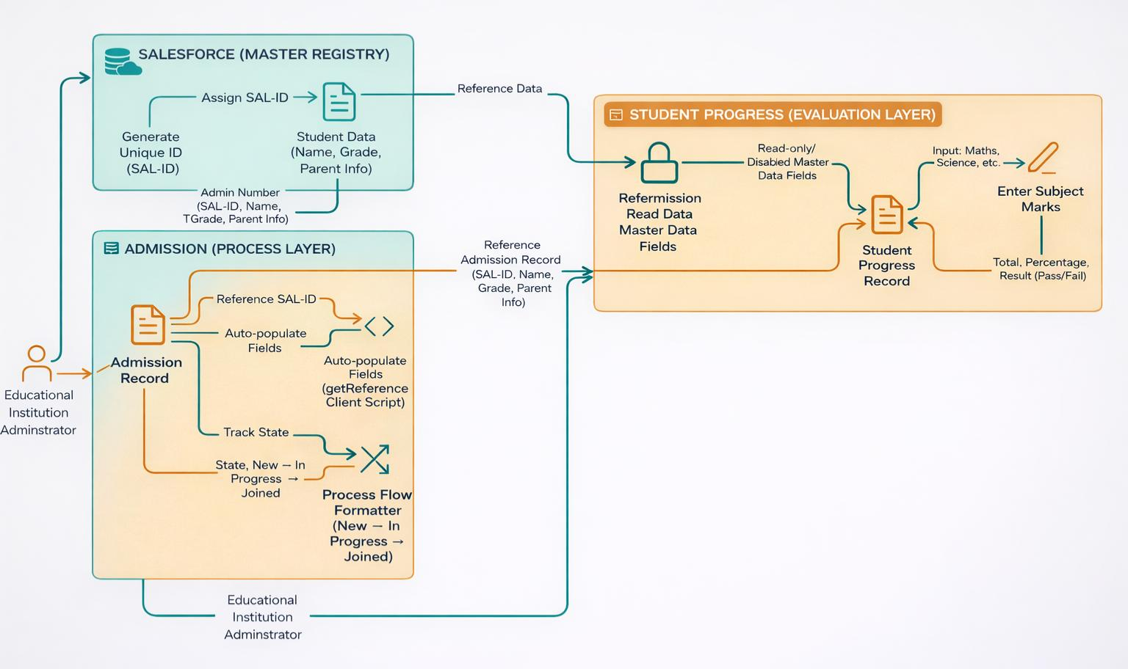
3.3 Data Flow Diagram

3.4 Technology Stack
- Platform: ServiceNow (Cloud-based PaaS)
- Database: u_salesforce, u_admission, u_student_progress
- Scripting: JavaScript (Client-side g_form API)
- UI Configuration: Form Designer & Process Flow Formatter

4. PROJECT DESIGN

4.1 Problem-Solution Fit
- Manual Gap: Disconnected systems create data duplication and slow admission processing.
- The Fit: ServiceNow centralizes records and eliminates repetitive manual data entry using automation scripts.

4.2 Proposed Solution
• Salesforce table as Master Registry.
• Process Flow Formatter for admission tracking.
• Client Scripts for automation and calculations.

4.3 Solution Architecture
• Relational Model using Reference fields.
• Client-side Glide Form scripting for real-time updates.

5. PROJECT PLANNING & SCHEDULING

5.1 Project Planning
- Weeks 1–2: Instance setup and Database Architecture.
- Weeks 3–4: UI configuration and Client Script implementation.
- Week 5: Functional testing and documentation.

6. FUNCTIONAL & PERFORMANCE TESTING

6.1 Performance Testing
• Efficiency: Script response time under 1 second.
• Accuracy: Instant and correct calculations.
• Security: Read-only protection of calculated fields.

7. RESULTS

7.1 Output Screenshots
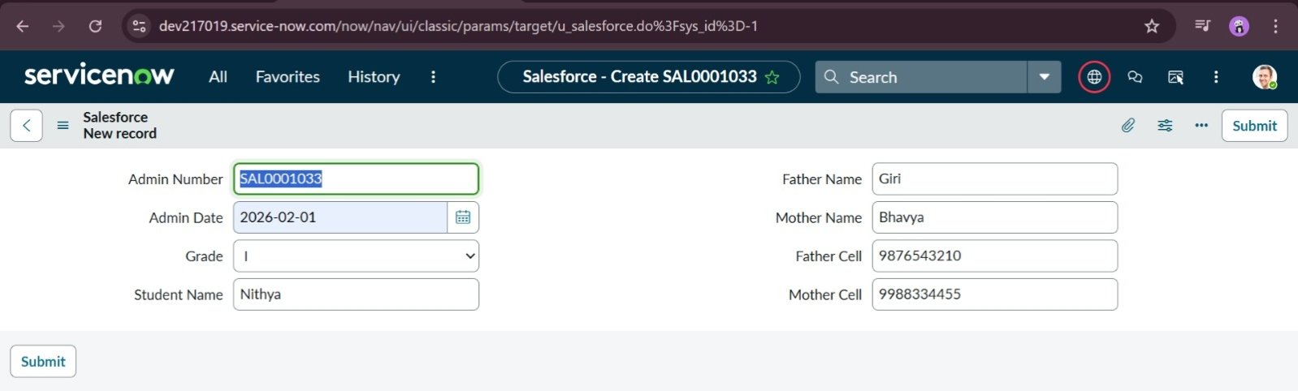
Figure 1: Salesforce master record with automated SAL ID generation.
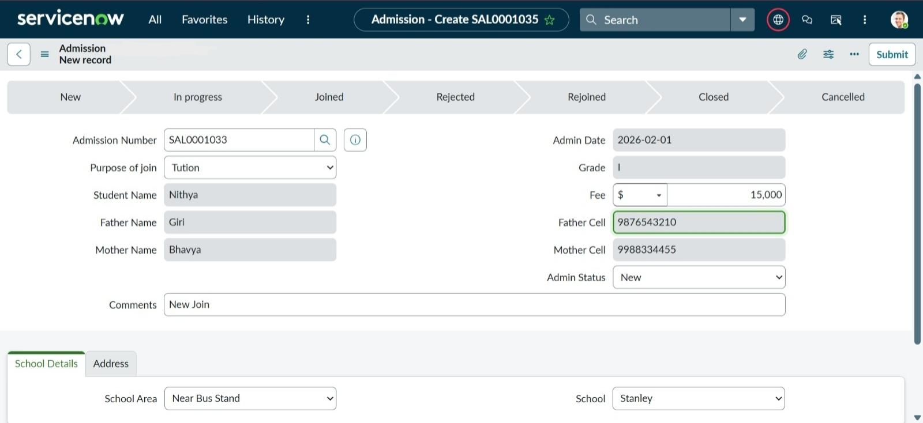
Figure 2.1: Admission form showing automated data retrieval via Client Scripting.
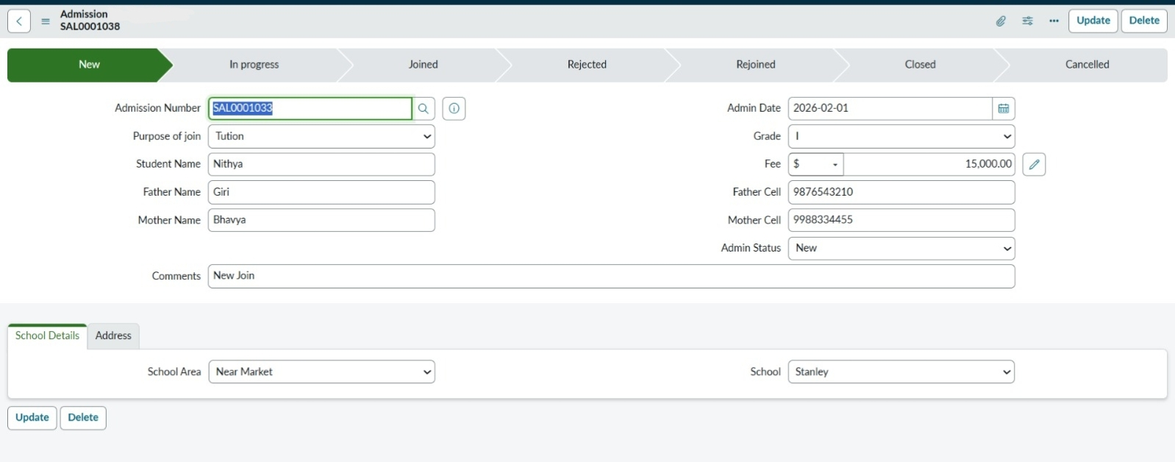
Figure 2.2: Admission record highlighting the Process Flow Formatter for lifecycle tracking.
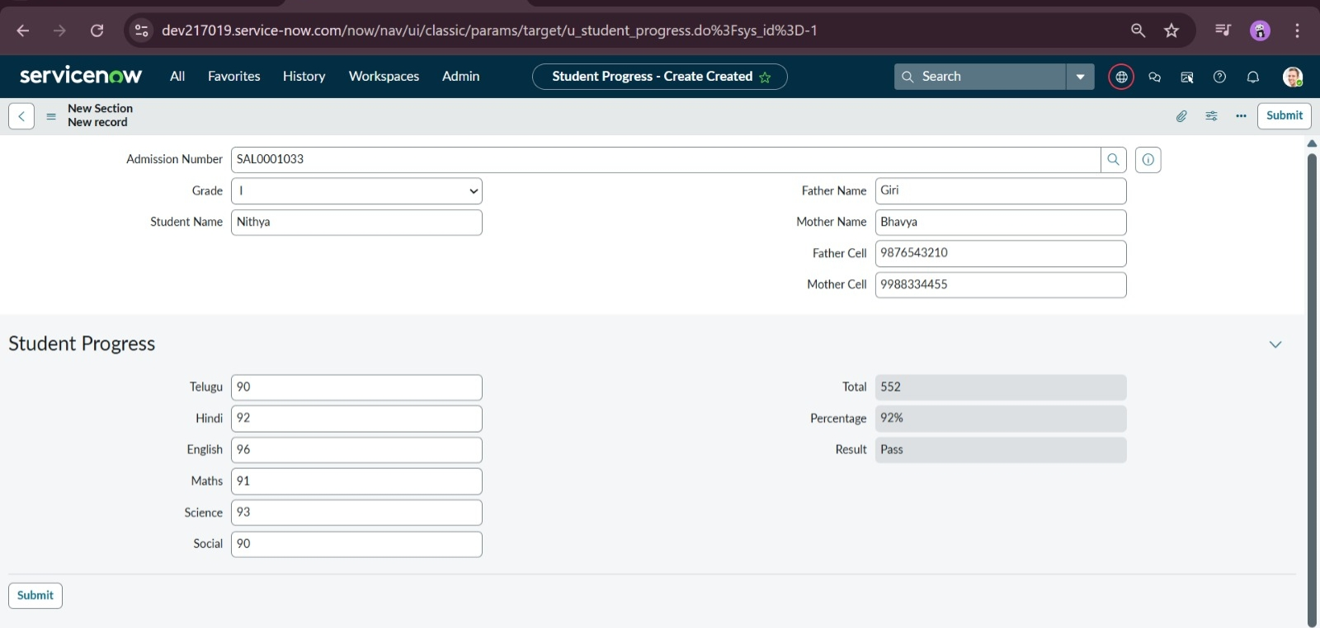
Figure 3: Academic evaluation form with real-time result calculation.
The system successfully demonstrates automated SAL ID generation, auto-population of admission data, real-time academic calculation, and lifecycle tracking using Process Flow Formatter.

8. ADVANTAGES & DISADVANTAGES
Advantages:
• Cloud-based system
• Fast low-code deployment
• Real-time data consistency
Disadvantages:
• Requires internet connectivity
• Requires basic ServiceNow knowledge

9. CONCLUSION
This project demonstrates the effectiveness of ServiceNow in digitizing educational administrative workflows. The integration of Salesforce, Admission, and Student Progress tables successfully automated data handling and academic tracking while ensuring accuracy and efficiency.

10. FUTURE SCOPE
• Real-time dashboards and analytics
• Email/SMS notifications
• Fee and Library management module integration

11. APPENDIX
• Source Code
Below are the key Client Scripts used in the application:
- Auto Populate Client Scripts for Admission Table
function onChange(control, oldValue, newValue, isLoading, isTemplate) {
if (isLoading || newValue === '') {
return;
}
var a = g_form.getReference('u_admission_number');
g_form.setValue('u_admin_date',a.u_admin_date);
g_form.setValue('u_grade',a.u_grade);
g_form.setValue('u_student_name',a.u_student_name);
g_form.setValue('u_father_name',a.u_father_name);
g_form.setValue('u_mother_name',a.u_mother_name);
g_form.setValue('u_father_cell',a.u_father_cell);
g_form.setValue('u_mother_cell',a.u_mother_cell);
g_form.setDisabled('u_admin_date',a.u_admin_date);
g_form.setDisabled('u_grade',a.u_grade);
g_form.setDisabled('u_student_name',a.u_student_name);
g_form.setDisabled('u_father_name',a.u_father_name);
g_form.setDisabled('u_mother_name',a.u_mother_name);
g_form.setDisabled('u_father_cell',a.u_father_cell);
g_form.setDisabled('u_mother_cell',a.u_mother_cell);
}
- Pincode Update Client Scripts for Admission Table
function onChange(control, oldValue, newValue, isLoading, isTemplate) {
if (isLoading || newValue === '') {
return;
}
var a = g_form.getValue('u_pincode');
if(a == '509358')
{
g_form.setValue('u_mandal', 'kadthal');
g_form.setValue('u_city', 'kadthal');
g_form.setValue('u_district', 'RangaReddy');
}
else if(a == '500081')
{
g_form.setValue('u_mandal', 'karmanghat');
g_form.setValue('u_city', 'karmanghat');
g_form.setValue('u_district', 'RangaReddy');
}
else if(a == '500079')
{
g_form.setValue('u_mandal', 'Abids');
g_form.setValue('u_city', 'AsifNagar');
g_form.setValue('u_district', 'Hyderabad');
}
- Disable Fields Client Scripts for Student progress Table
function onLoad() {
g_form.setDisabled('u_total',true);
g_form.setDisabled('u_percentage',true);
g_form.setDisabled('u_result',true);
}
- Total Update Client Scripts for Student progress Table
function onChange(control, oldValue, newValue, isLoading, isTemplate) {
if (isLoading || newValue === '') {
return;
}
if (newValue){
var a = parseInt(g_form.getValue('u_telugu'));
var b = parseInt(g_form.getValue('u_hindi'));
var c = parseInt(g_form.getValue('u_english'));
var d = parseInt(g_form.getValue('u_maths'));
var e = parseInt(g_form.getValue('u_science'));
var f = parseInt(g_form.getValue('u_social'));
var Total = parseInt(a+b+c+d+e+f);
g_form.setValue('u_total', Total);
}
}
- Result Client Scripts for Student progress Table
function onChange(control, oldValue, newValue, isLoading, isTemplate) {
if (isLoading || newValue === '') {
return;
}
if(newValue) {
var a = parseInt(g_form.getValue('u_percentage')); // Convert the value to an integer for comparison
if(a >= 0 && a <= 59){
g_form.setValue('u_result','Fail');
} else if(a >= 60 && a <= 100) {
g_form.setValue('u_result','Pass');
} else {
// Handle the case if a is out of range (optional)
g_form.addErrorMessage('Percentage should be between 0 and 100.');
g_form.clearValue('u_result');
}
}
}
- Percentage Client Scripts for Student progress Table
function onChange(control, oldValue, newValue, isLoading, isTemplate) {
if (isLoading || newValue === '') {
return;
}
var Total = g_form.getValue('u_total');
var Percentage = (Total/600)*100;
g_form.setValue('u_percentage',Percentage+'%');
}

- GitHub Link:
https://github.com/MulintiHimasree/Educational-Organisation-using-ServiceNow
- Demo Video Link:
https://drive.google.com/file/d/14ZHvtxgxkd6MDguu4SVrPP91UKxo9Vjn/view?usp=drivesdk

